1. Write a program to perform the following

o An empty list

o A list with one element

o A list with all identical elements

o A list with negative numbers

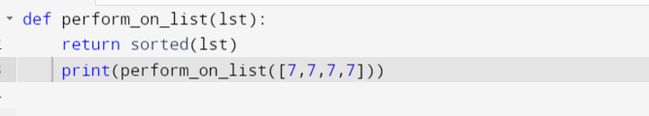

2. Describe the Selection Sort algorithm's process of sorting an array. Selection Sort works

by dividing the array into a sorted and an unsorted region. Initially, the sorted region is

empty, and the unsorted region contains all elements. The algorithm repeatedly selects

the smallest element from the unsorted region and swaps it with the leftmost unsorted

element, then moves the boundary of the sorted region one element to the right. Explain

why Selection Sort is simple to understand and implement but is inefficient for large

datasets. Provide examples to illustrate step-by-step how Selection Sort rearranges the

elements into ascending order, ensuring clarity in your explanation of the algorithm's

mechanics and effectiveness.

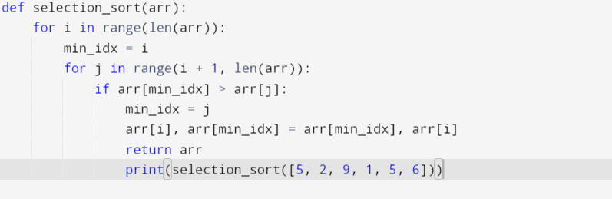

3. Write code to modify bubble_sort function to stop early if the list becomes sorted before

all passes are completed.

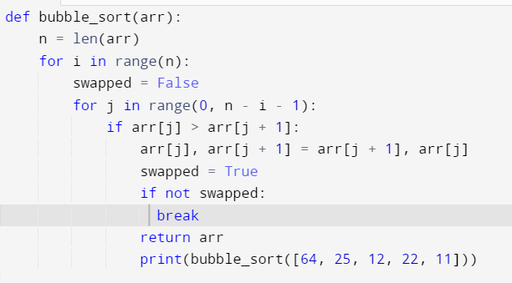

4. Write code for Insertion Sort that manages arrays with duplicate elements during

the sorting process. Ensure the algorithm's behavior when encountering duplicate

values, including whether it preserves the relative order of duplicates and how it

affects the overall sorting outcome.

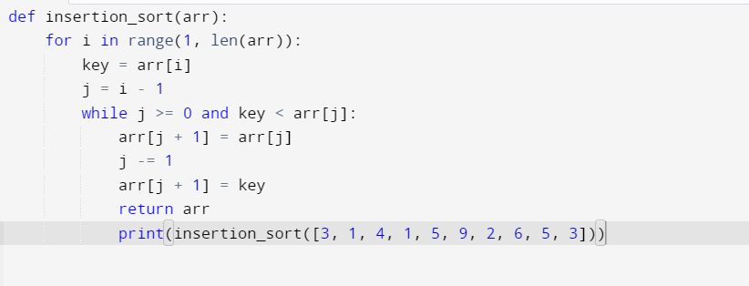

5. Given an array arr of positive integers sorted in a strictly increasing order, and an integer k. return

the kth positive integer that is missing from this array.

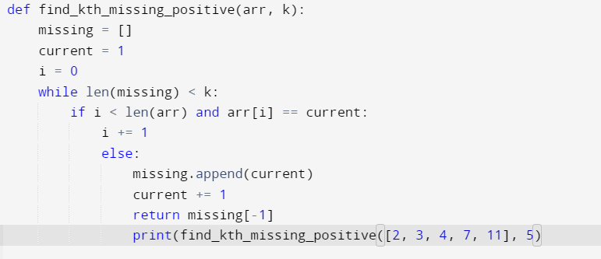

6. A peak element is an element that is strictly greater than its neighbors. Given a 0-indexed integer

array nums, find a peak element, and return its index. If the array contains multiple peaks, return

the index to any of the peaks. You may imagine that nums[-1] = nums[n] = -∞. In other words,

an element is always considered to be strictly greater than a neighbor that is outside the array.

You must write an algorithm that runs in O(log n) time.

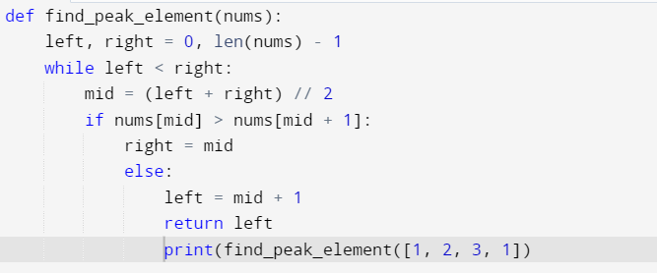

7. Given two strings needle and haystack, return the index of the first occurrence of needle in

haystack, or -1 if needle is not part of haystack.

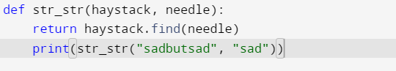

8. Given an array of string words, return all strings in words that is a substring of another word. You

can return the answer in any order. A substring is a contiguous sequence of characters within a

string

